* **Generic class**

VD:

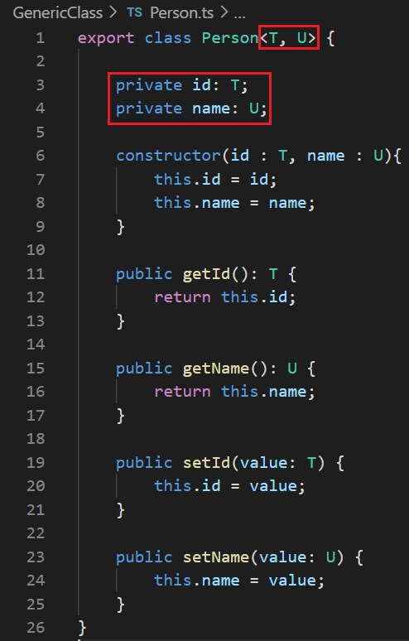 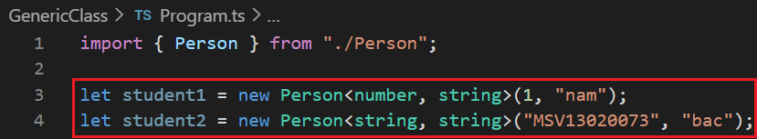

* **Generic function**

VD:

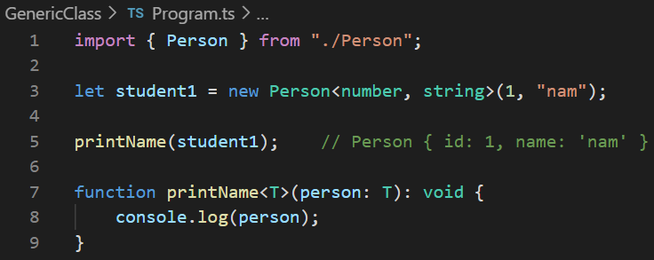

* **Wildcard keyword**

VD:

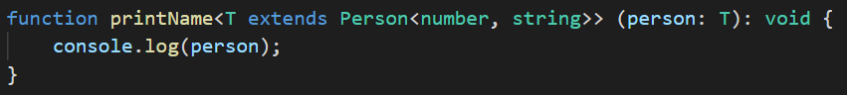

* **Reference**

<http://www.typescriptlang.org/docs/handbook/generics.html>

<https://www.javatpoint.com/typescript-generics>